Report: KSD(Korea Securities Depositories)에서의 GPTs 도입 전략

# Introduction to GPTs in the KSD

### Introduction to GPTs in the KSD  
  
In recent years, the landscape of artificial intelligence has seen significant advancements, particularly with the introduction of Generative Pre-trained Transformers (GPTs) by OpenAI. These innovations serve as customized iterations of the ChatGPT model, designed to address distinct user needs and enhance the interactivity of AI in daily routines. The advent of GPTs marks a pivotal moment in the evolution of AI technology, as it offers a higher level of personalization and functionality than its predecessors.  
  
OpenAI's introduction of GPTs was prominently outlined during their Dev Day, celebrated for its potential to merge the capabilities of ChatGPT with tailored instructions, contextual knowledge, and specific skill sets. These custom versions are engineered to perform a wide array of tasks, making them suitable for various applications ranging from corporate environments to educational settings. For instance, organizations can create GPT variants that align with their internal protocols, ultimately fostering efficiency and innovation within business processes.  
  
The growing emphasis on specialized AI solutions reflects an increasing demand for tools that can be finely tuned to meet users' individual needs. As noted in recent discourse, GPTs aim to make artificial intelligence not only more applicable but integral to everyday workflows. This level of customization is critical for users who seek solutions that go beyond generic capabilities, facilitating a more meaningful interaction with technology.  
  
In education, the potential of GPTs is just beginning to be realized. The integration of these AI powerhouses into classroom settings heralds a transformative shift in educational methodologies. Educators and students alike stand to benefit from a tailored learning experience, where the technology can adapt to diverse learning styles and requirements, thus enhancing educational outcomes and engagement.  
  
As we explore the implications and applications of GPTs, it is essential to recognize their role in shaping the future of AI and the intersection between technology and user experience. The customization capabilities of GPTs are not only innovative but also provide a roadmap for how we might interact with various facets of our lives—be it in business, education, or daily personal tasks. With this level of adaptability and integration, GPTs represent a significant leap forward in making artificial intelligence a more accessible and beneficial tool for everyone.

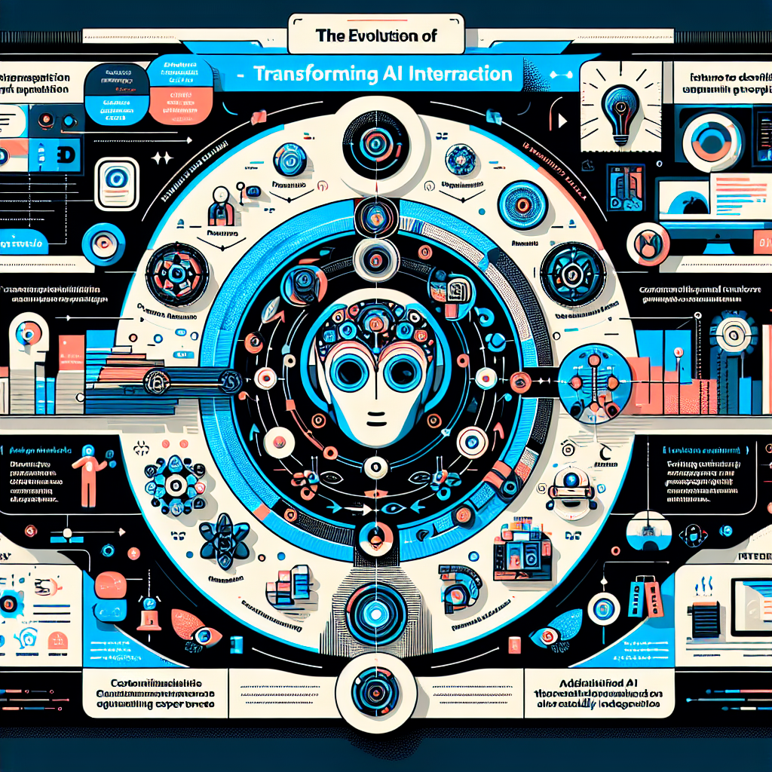

Image prompt: Create an infographic that visually represents the key points from the "Introduction to GPTs in the KSD" section. Include the following elements:  
  
1. **Title**: "The Evolution of GPTs: Transforming AI Interaction"  
2. **Key Milestones**: Highlight the introduction of Generative Pre-trained Transformers (GPTs) by OpenAI, especially during Dev Day.  
3. **Customization Focus**: Illustrate how GPTs enhance personalization with tailored instructions and contextual knowledge.  
4. **Applications**: Use icons or images to represent different environments like corporate settings and education, showcasing GPTs' versatility.  
5. **Benefits in Education**: Emphasize the potential for improved learning experiences through adaptability to diverse learning styles.  
6. **Future of AI**: Conclude with a vision of how GPTs shape the user experience and integrate into daily life.  
  
Use a modern and engaging design with color-coded sections and clear visuals to make the information easily digestible.

# Current Landscape of Securities Depositories in Korea

### Current Landscape of Securities Depositories in Korea  
  
The securities depository system in Korea has undergone substantial advancements and continues to be a crucial component of the country's financial ecosystem. At the heart of this system is the Korea Securities Depository (KSD), which serves as the central securities depository (CSD) for the Republic of Korea. The KSD plays a fundamental role not just in safeguarding securities but also in facilitating their efficient settlement and trade.  
  
#### Overview of the Korea Securities Depository (KSD)  
  
Established to ensure a high standard of security for financial assets and to promote the stability of the financial market, the KSD is a member of the Asia Pacific Central Securities Depository Group Association (ACG). Its primary functions include holding securities in electronic form, managing settlement processes, and providing services for the issuance of securities. This modern architecture has enabled the KSD to enhance transparency, reduce risks related to physical manuscript securities, and promote greater institutional efficiency in trading activities.  
  
#### Regulatory Developments and Emerging Trends  
  
As the financial landscape continues to evolve, so does the regulatory environment surrounding the securities market in Korea. The recent cessation of discussions regarding Security Token Offerings (STOs) within the National Assembly indicates an ongoing struggle to establish stable regulatory frameworks for innovative financial products. Notably, STO-related bills were abandoned at the end of the 21st National Assembly's term, reinforcing the necessity of a well-defined legal framework as these initiatives are anticipated to be reintroduced during the 22nd National Assembly.   
  
This development highlights the tension between innovation and regulation, an area where the KSD will likely play a pivotal role in aligning with new legislative approvals, ensuring that emerging technologies can integrate seamlessly into existing systems.   
  
#### Challenges and Market Dynamics  
  
Current discussions surrounding the operational efficiency of securities depositories in Korea also reveal certain challenges. Specifically, there are concerns regarding the absence of liquidity and the concentration risk add-on charges under the prevailing margin methodology, which applies to both listed securities and the broader securities trading landscape. These factors can introduce complexities for market participants, including institutional investors, who rely heavily on a predictable and stable trading environment.  
  
The KSD's efforts to address these challenges are critical for maintaining investor confidence and ensuring the robustness of Korea's capital markets. By actively engaging in discussions around risk management methodologies and liquidity enhancement strategies, the KSD is positioned to strengthen the foundational ecosystem on which the securities market operates.  
  
#### Outlook and Future Prospects  
  
Looking ahead, the KSD must navigate the dual challenges of regulatory integration and market efficiency to maintain its pivotal role in nurturing the growth of Korea's financial markets. As it continues to evolve, a potential shift towards digital asset management and the incorporation of blockchain technology could augment the current services provided by the KSD, further enhancing security and efficiency.  
  
The landscape of securities depositories in Korea is characterized by its adaptability to changing market dynamics and regulatory frameworks, led by the KSD's efforts in maintaining stability and promoting innovation within the capital markets. Therefore, the connection between legislative developments and KSD functions will be a crucial area to watch in the coming years, particularly within the context of global financial trends and local market resilience.   
  
In summary, the current landscape of securities depositories in Korea centers around the KSD's central role, ongoing regulatory developments concerning innovative financial products, and strategic initiatives aimed at overcoming market challenges, all contributing to the anticipation of a more robust and inclusive securities ecosystem.

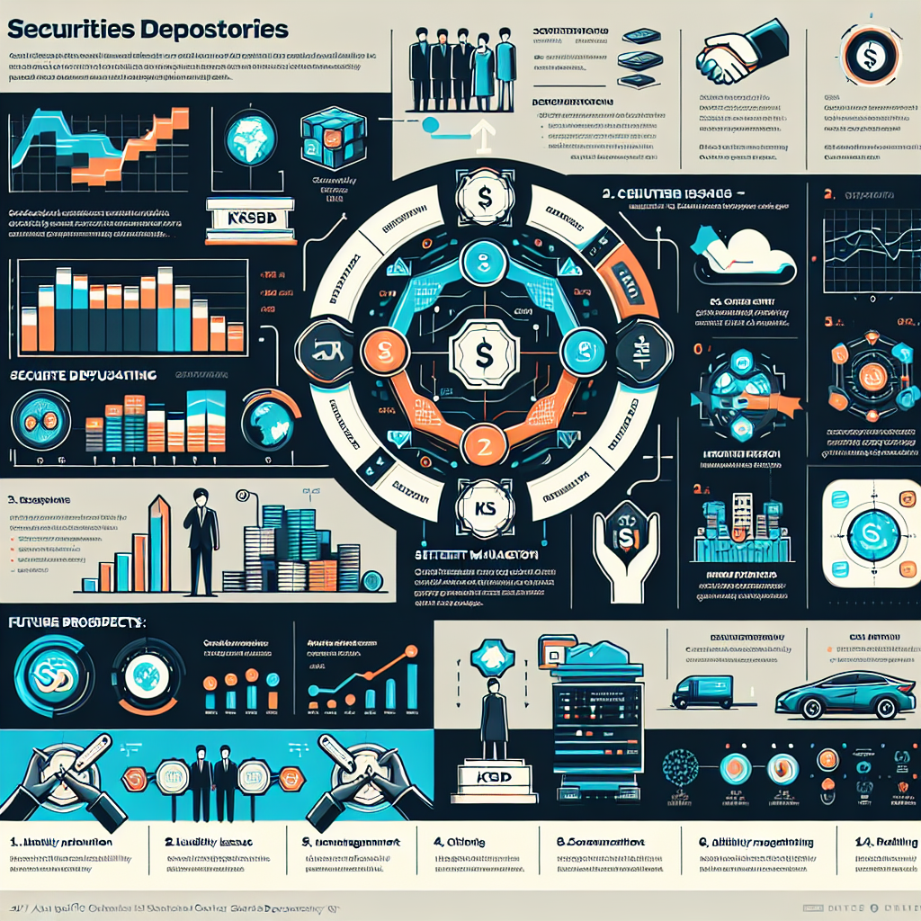

Image prompt: Create an engaging infographic that visually represents the current landscape of securities depositories in Korea, focusing on the Korea Securities Depository (KSD). Key elements to include are:   
  
1. **Overview of KSD**: Highlight its establishment, primary functions (holding securities, managing settlements, issuance services), and membership in the Asia Pacific Central Securities Depository Group.  
   
2. **Regulatory Developments**: Illustrate the tension between innovation and regulation, specifically regarding Security Token Offerings (STOs) and the necessity for a robust legal framework.  
  
3. **Challenges and Market Dynamics**: Showcase current challenges, such as liquidity concerns and risk add-on charges, affecting institutional investors.  
  
4. **Outlook and Future Prospects**: Emphasize the potential integration of digital assets and blockchain technology, and the KSD's role in enhancing market stability and innovation.  
  
Use icons, charts, and bullet points to make the information visually appealing and easy to understand.

# Benefits of Implementing GPTs at KSD

### Benefits of Implementing GPTs at KSD  
  
Implementing Generative Pre-trained Transformers (GPTs) at the Korea Securities Depository (KSD) has the potential to significantly enhance operational efficiency, improve customer interactions, and streamline processes. Below are key benefits that KSD can expect from the adoption of these advanced AI technologies.  
  
#### 1. Cost-Effectiveness  
  
The implementation of GPTs, such as GPT Plus, presents KSD with a cost-effective solution. Given their affordable monthly cost, GPTs can be utilized across various business functions without necessitating substantial financial investments. This affordability allows KSD to allocate resources toward other critical areas while leveraging AI for increased productivity and efficiency.  
  
#### 2. Enhanced Customer Support  
  
One of the most substantial advantages of utilizing GPTs is the enhancement of customer support services. KSD can deploy GPT-powered chatbots to provide efficient, round-the-clock assistance to clients, addressing common inquiries about securities, transactions, and market conditions. As noted in recent analyses, AI chatbots improve response times and enhance user satisfaction by delivering personalized assistance, which is crucial in competitive financial markets where timely information is paramount.  
  
#### 3. Improved Data Management and Analysis  
  
GPTs can automate the processing and analysis of large volumes of data, allowing KSD to extract actionable insights quickly. By employing AI to handle data management tasks, KSD staff can focus on higher-value activities, such as strategic planning and risk management. This capability can lead to better decision-making processes and enhance KSD’s overall operational efficacy.  
  
#### 4. Customizability and Flexibility  
  
The ability to create customized versions of GPTs allows KSD to tailor AI solutions specifically to its operational needs. This means that KSD can design GPT models that align with its internal processes and compliance requirements, thus ensuring that the technology fits seamlessly into its existing frameworks. Such customizability enhances the potential for innovation within KSD’s services and promotes more meaningful interactions with clients.  
  
#### 5. Improved Regulatory Compliance  
  
GPTs can also play a vital role in ensuring regulatory compliance by automating the monitoring of transactions and generating compliance reports. By harnessing the capabilities of AI, KSD can maintain a vigilant oversight of trading activities, ensuring alignment with evolving regulations and minimizing the risks of non-compliance.  
  
#### 6. Increased Analytical Capabilities  
  
With their ability to process and analyze data at scale, GPTs can enhance KSD's analytical capabilities, allowing for sophisticated forecasting models and risk assessments. By understanding market trends more accurately, KSD can proactively address potential issues and better serve its clients' needs.  
  
#### 7. Streamlined Internal Processes  
  
The adoption of GPTs facilitates the automation of repetitive internal tasks, from document generation to data entry. The reduction of manual labor not only increases overall efficiency but also minimizes the risk of human error. This streamlining allows KSD employees to dedicate more time to strategic initiatives that add greater value to the organization.  
  
#### 8. Enhanced Communication  
  
GPTs can also improve internal communication within KSD. They can serve as intelligent assistants that help manage email responses, prepare reports, and summarize meetings, thus enabling employees to focus on complex tasks that require human insight and creativity.  
  
#### Conclusion  
  
Incorporating GPTs into operations at KSD stands to revolutionize its workflow and customer interaction paradigms by harnessing advanced AI capabilities. By adopting these technologies, KSD can achieve significant cost savings, improve customer support, enhance regulatory compliance, and propel its overall effectiveness in the fast-paced financial services sector. These advancements are not just about keeping up with technological evolution; they position KSD as a forward-thinking leader within the financial ecosystem.

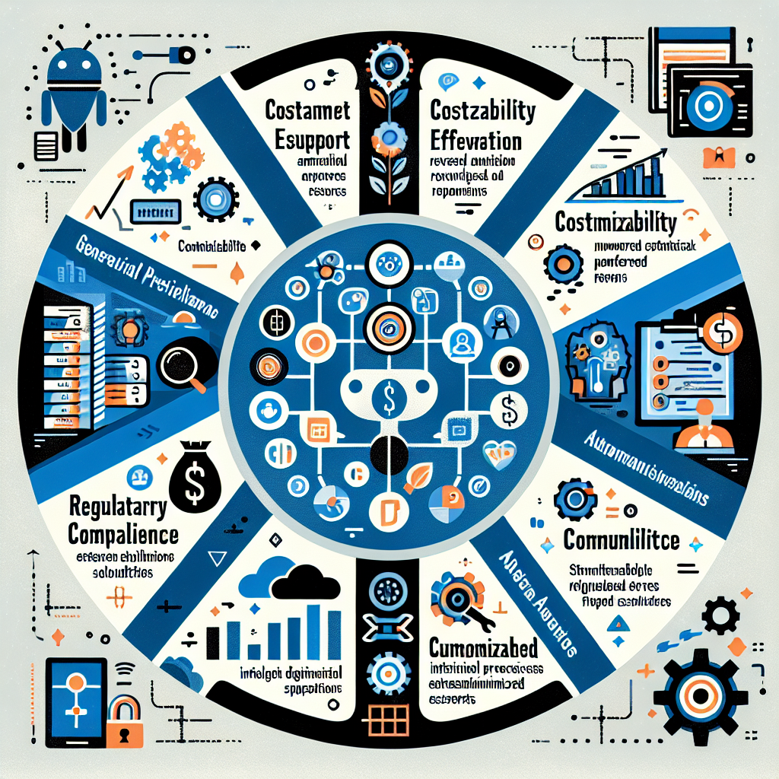

Image prompt: Create an infographic that captures the benefits of implementing Generative Pre-trained Transformers (GPTs) at the Korea Securities Depository (KSD). Include the following key points:  
  
1. **Cost-Effectiveness**: Highlight affordability and resource allocation.  
2. **Enhanced Customer Support**: Showcase GPT-powered chatbots and improved response times.  
3. **Improved Data Management**: Illustrate automation in data processing for better decision-making.  
4. **Customizability**: Emphasize tailored AI solutions for internal processes.  
5. **Regulatory Compliance**: Represent automated transaction monitoring and compliance reporting.  
6. **Increased Analytical Capabilities**: Indicate enhanced forecasting and risk assessments.  
7. **Streamlined Internal Processes**: Visualize automation of repetitive tasks and reduction of manual labor.  
8. **Enhanced Communication**: Depict intelligent assistants improving internal communication.  
  
Incorporate visuals and icons to represent AI, financial services, and operational efficiency. Use a modern design to convey innovation and leadership in the financial ecosystem.

# Challenges and Considerations for GPTs Adoption

### Challenges and Considerations for GPTs Adoption  
  
While the adoption of Generative Pre-trained Transformers (GPTs) presents numerous opportunities for organizations like the Korea Securities Depository (KSD), it also comes with several challenges and considerations that need to be addressed. Understanding these challenges is crucial for a successful implementation of GPTs to enhance operational efficiency and customer interaction.  
  
#### 1. Job Displacement Concerns  
  
One of the significant barriers to the widespread adoption of GPT technology is the concern over job displacement. The introduction of advanced AI systems raises fears among employees about potential job losses as tasks are automated. Businesses must proactively manage these fears by reskilling and upskilling their workforce to ensure that employees can adapt to new roles that complement AI technologies rather than compete with them. Effective change management strategies and clear communication can help in alleviating these concerns and fostering a culture of collaboration between humans and AI.  
  
#### 2. Ethical Considerations  
  
The deployment of GPTs inherently raises ethical questions related to bias, accountability, and transparency. As noted in discussions around ethical AI development, it is essential to ensure that GPTs are designed to minimize biases in their outputs and decisions. Organizations must implement rigorous testing and validation processes to identify any biases present in their models, leading to fairer outcomes in applications such as customer support and data analysis. Furthermore, maintaining transparency in how GPTs derive their conclusions is critical for building trust among users and stakeholders.  
  
#### 3. Lack of Transparency  
  
A significant challenge for businesses using GPT technology is the inherent opacity of AI systems. Many organizations struggle to understand how decisions made by GPTs are reached, creating difficulties in justifying these decisions, especially within regulated industries such as finance. KSD should consider implementing explainable AI frameworks that maintain a level of interpretability of the model's outcomes. This will not only help in meeting regulatory requirements but also enhance user trust in the technology.  
  
#### 4. Intellectual Property and Data Security  
  
The implementation of GPTs involves considerations around intellectual property (IP) and data security. Organizations must be aware of how their proprietary information might be utilized or misappropriated by AI systems. As businesses integrate GPTs into their operations, they need to establish clear guidelines regarding data usage, storage, and security measures to protect sensitive information from potential breaches. Furthermore, ensuring compliance with data protection regulations is crucial for mitigating the risks associated with data handling.  
  
#### 5. Misalignment with Business Goals  
  
For a successful GPT integration, it is essential for organizations to ensure that their AI initiatives align with broader business objectives. If GPTs are deployed without a clear connection to strategic goals, there’s a risk that they may not deliver the anticipated value or return on investment. Companies should engage in careful planning and stakeholder involvement to ensure that the implementation of GPT technologies complements existing processes and drives organizational growth.  
  
#### 6. Infrastructure and Integration Challenges  
  
The integration of GPTs may require modifications to existing IT infrastructure, which can pose logistical challenges. Organizations may need to invest in infrastructure enhancements or support services that facilitate the smooth functioning of AI systems. Additionally, compatibility issues with legacy systems could hinder seamless integration, posing further challenges in adopting this technology. Strategic partnerships with technology providers may be necessary to overcome these barriers and enable efficient system synchronization.  
  
#### 7. Cultural Resistance  
  
Adopting innovative technologies like GPTs may face resistance from organizational culture, particularly in traditional workplaces. Employees accustomed to established processes may be wary of adopting AI-driven solutions. To counter this, organizations should foster a culture of innovation and digital literacy, encouraging experimentation and open-mindedness towards new technologies. Involving staff early in the conversation about AI adoption can enhance buy-in and decrease resistance.  
  
#### Conclusion   
  
In summary, while the adoption of GPTs at KSD holds great potential for enhancing organizational efficiency and improving customer interactions, various challenges must be acknowledged and addressed. Job displacement concerns, ethical considerations, lack of transparency, intellectual property and data security issues, misalignment with business goals, infrastructure integration challenges, and cultural resistance are critical factors that must be navigated carefully. By recognizing these challenges and proactively developing strategies to mitigate their impact, KSD can position itself for successful integration of GPT technologies, maximizing their benefits while ensuring organizational resilience and ethical compliance.

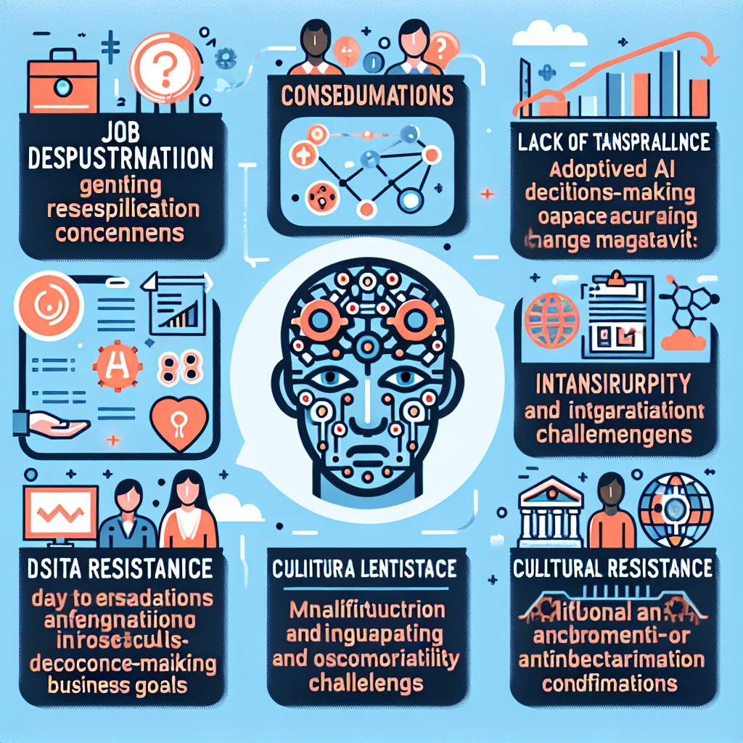

Image prompt: Create an infographic illustrating the challenges and considerations for adopting Generative Pre-trained Transformers (GPTs) in organizations like the Korea Securities Depository (KSD). Include the following key points:  
  
1. **Job Displacement Concerns**: Highlight the need for reskilling and proactive change management.  
2. **Ethical Considerations**: Emphasize the importance of reducing bias and ensuring transparency.  
3. **Lack of Transparency**: Address the challenges of AI decision-making opacity and the need for explainable AI.  
4. **Intellectual Property and Data Security**: Illustrate the importance of protecting proprietary information and complying with data regulations.  
5. **Misalignment with Business Goals**: Show the importance of aligning AI initiatives with strategic objectives.  
6. **Infrastructure and Integration Challenges**: Discuss the potential need for IT enhancements and compatibility solutions.  
7. **Cultural Resistance**: Depict strategies for fostering an innovative culture within the organization.  
  
Use engaging visuals and icons to represent each point effectively.

# Strategic Roadmap for Implementation

### Strategic Roadmap for Implementation  
  
A Strategic Roadmap is an essential tool that helps organizations translate high-level strategic goals into specific actionable initiatives and projects. For the Korea Securities Depository (KSD), implementing Generative Pre-trained Transformers (GPTs) can significantly enhance operational effectiveness and customer engagement. This roadmap outlines the critical steps and milestones that will guide KSD in successfully implementing and integrating GPT technologies into its operations.  
  
#### 1. Define Clear Objectives and Goals  
  
The first step in developing a strategic roadmap is to clarify the specific objectives KSD aims to achieve through the implementation of GPTs. These could include enhancing customer support services, improving data management, and ensuring compliance with regulatory requirements. Aligning these goals with the overall business strategy is vital for maintaining focus and maximizing the impact of AI technology.  
  
#### 2. Conduct a Needs Assessment  
  
A thorough needs assessment should be conducted to identify areas within KSD's operation that could benefit from GPT integration. This involves evaluating existing workflows and identifying pain points that GPTs could address, such as automating repetitive tasks, streamlining communication, or enhancing data analysis capabilities. By determining these specific needs, KSD can develop tailored solutions that resonate with its strategic priorities.  
  
#### 3. Develop a Comprehensive Implementation Plan  
  
The next step is to create a structured implementation plan that outlines the necessary processes, resources, and timelines for rolling out GPT solutions. The plan should include:  
  
- **Milestones**: Identify key milestones that will indicate progress towards the overall goals. For example, successful deployment of a customer support chatbot, the completion of employee training on AI systems, or the establishment of data monitoring practices.  
  
- **Resource Allocation**: Determine required resources, including technology, budget, and personnel. This involves estimating the financial investment in GPT technology and allocating budget accordingly to cover personnel training, system integration, and maintenance.  
  
- **Team Responsibilities**: Assign responsibilities to ensure accountability and clarity in the implementation process. Designate project leaders, IT specialists, and compliance officers who will oversee their respective areas.  
  
#### 4. Engage Stakeholders and Foster Collaboration  
  
Successful implementation of GPT technologies demands collaboration among various stakeholders within KSD. Engaging staff at all levels—from executives to frontline employees—will ensure that everyone is informed and invested in the changes taking place. Regular communication about the goals and expectations surrounding GPT integration will help build trust and reduce resistance to change.  
  
Additionally, consider forming a cross-functional implementation team that brings together expertise from different departments, such as IT, compliance, and customer service. This approach fosters a holistic viewpoint, ensuring that all potential impacts of the new technology are considered.  
  
#### 5. Build Technical Capacity and Infrastructure  
  
A foundational element for effective GPT implementation is a robust technological infrastructure. KSD should assess its current IT capabilities and determine if any upgrades are necessary to support AI technologies. This includes ensuring data security and compliance with relevant regulations, as KSD handles sensitive financial information.  
  
- **Training and Development**: Provide necessary training for employees to effectively work with newly implemented GPT systems. This training should encompass both technical skills and an understanding of how AI can enhance their roles.  
  
- **Integration with Legacy Systems**: Address any potential integration issues with existing systems to ensure compatibility with GPT solutions. This may involve collaborating with technology providers to develop customized interfaces or bridges between different software applications.  
  
#### 6. Monitor Progress and Evaluate Impact  
  
Implementing a system for continuous monitoring and evaluation will be critical in assessing the effectiveness of GPT applications within KSD. This monitoring should focus on:  
  
- **Performance Metrics**: Establish key performance indicators (KPIs) that align with the objectives set during the planning phase. These could include metrics for improved customer response times, reductions in operational costs, or enhanced compliance rates.  
  
- **Feedback Mechanisms**: Create channels for employee and client feedback to evaluate the effectiveness of GPT solutions. Retaining this openness can help identify areas for further improvement and allow KSD to make data-driven decisions for future AI enhancements.  
  
#### 7. Iterate and Adapt  
  
Finally, the Strategic Roadmap should include a framework for iterating and adapting the implementation strategy based on performance evaluations and feedback received. As the financial landscape and technology continuously evolve, KSD must remain agile, adjusting its strategies and goals as necessary to leverage emerging capabilities and meet the changing needs of its clients.  
  
#### Conclusion  
  
In summary, the Strategic Roadmap for implementing GPTs at KSD serves as a comprehensive guide to navigate the complexities of AI integration into its operations. By clearly defining objectives, conducting a needs assessment, developing an implementation plan, engaging stakeholders, building technical capacity, monitoring progress, and fostering adaptability, KSD can position itself as a leader in the evolving landscape of financial technology. This structured approach will not only enhance operational efficiency but also elevate the overall customer experience, ensuring KSD remains at the forefront of innovation in the financial sector.

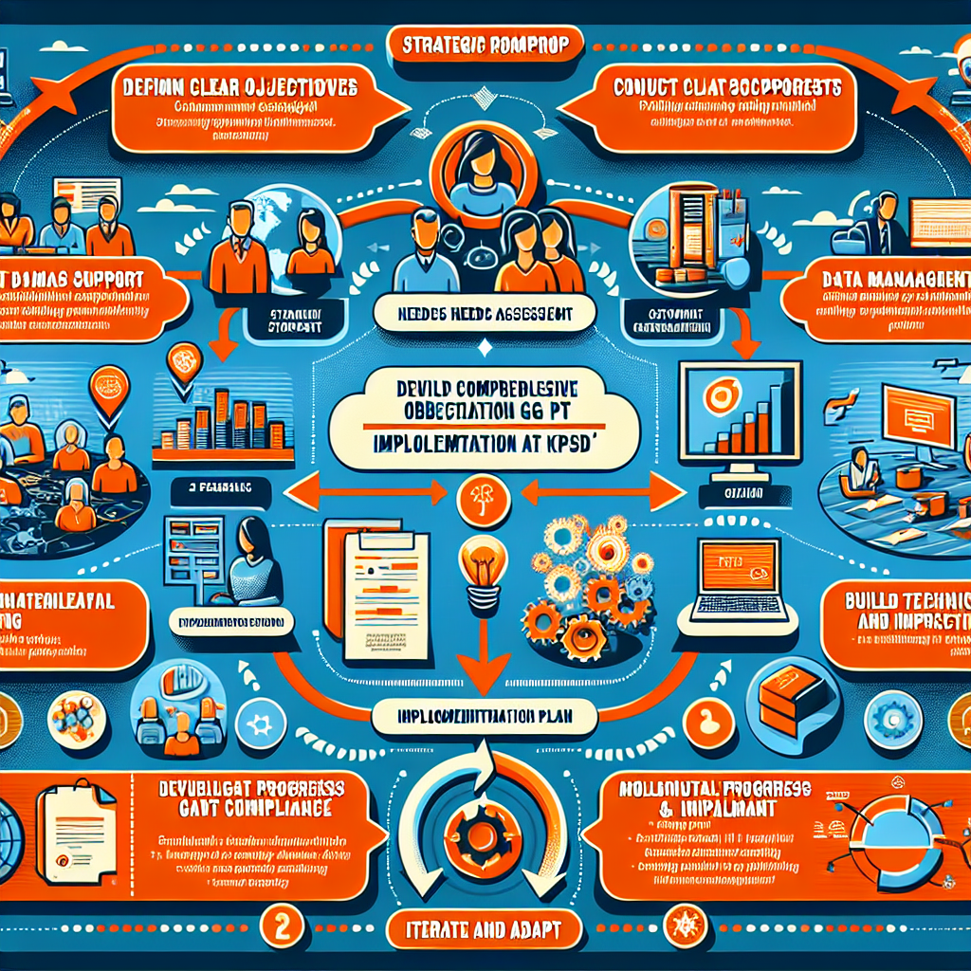

Image prompt: Create an infographic that visually represents the "Strategic Roadmap for Implementation" of Generative Pre-trained Transformers (GPTs) at the Korea Securities Depository (KSD). Include the following key elements:  
  
1. **Title**: "Strategic Roadmap for GPT Implementation at KSD"  
2. **Sections**:  
 - **Define Clear Objectives and Goals**: Use icons to depict customer support, data management, and compliance.  
 - **Conduct a Needs Assessment**: Flowchart highlighting areas needing integration (workflows, pain points).  
 - **Develop Comprehensive Implementation Plan**: Milestones, resource allocation (budget, personnel), and team responsibilities.  
 - **Engage Stakeholders and Foster Collaboration**: Diverse team visuals and communication flow.  
 - **Build Technical Capacity and Infrastructure**: IT capabilities, training, and integration symbols.  
 - **Monitor Progress and Evaluate Impact**: KPI metrics and feedback channels.  
 - **Iterate and Adapt**: Circular graphic illustrating adaptability and evolution.  
  
Use bold colors and clear icons to enhance readability and engagement.